# Consider the following Django models:

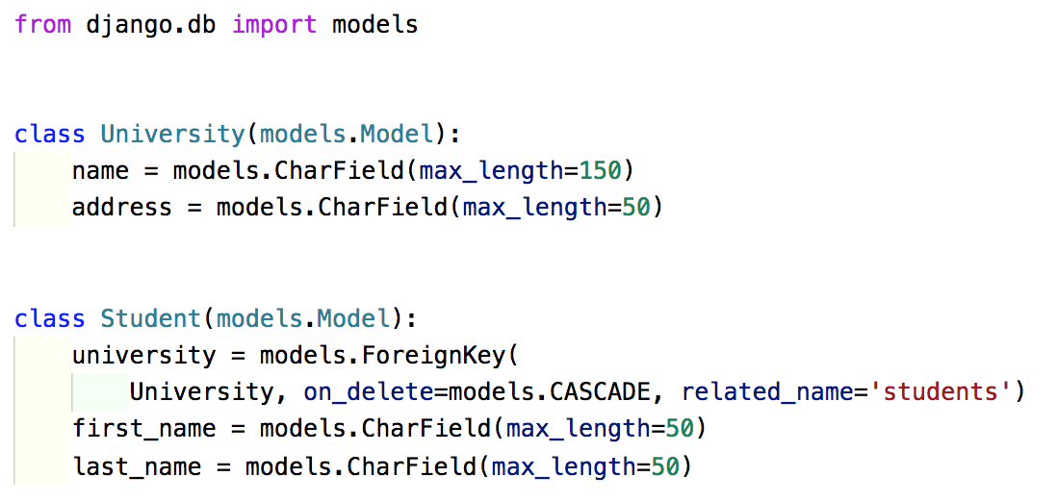

* 1. How do you read a University named “University of Otago” from the database?

**University.objects.filter(name__exact=”University of Otago”)**

* 1. Print all students from “University of Otago” (first and last name).

**university = University.objects.get(name=”University of Otago”)**

**student = Student.objects.filter(university=university)**

**for s in students:**

**first_name = s.first_name**

**last_name= s.last_name**

**{% for s in students %}**

**{{s.first_name}} {{s.last_name}}**

**{%endfor%}**

# Write a test case for the following class:

Check the Python file.